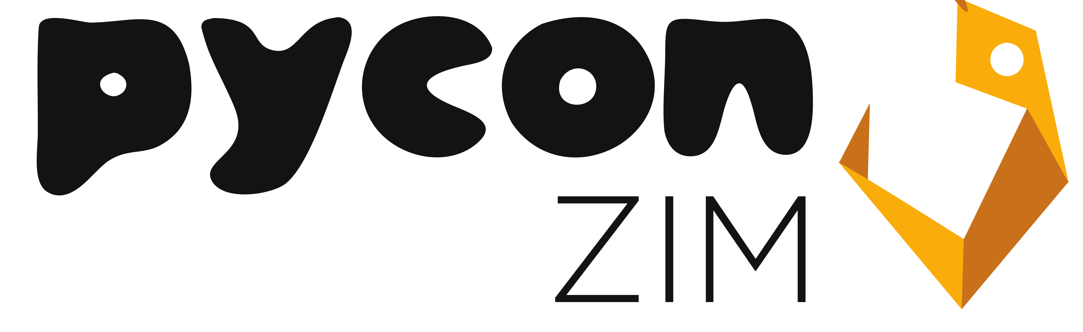

Sponsorship Prospectus

**Overview**

Date: 24 ­ 25 November 2016

Website: https://pyzim.github.io

Attendees: Approximately 100

Organizer: PyCon Zim Organizing Team

**What is PyCon**

PyCon (https://en.wikipedia.org/wiki/Python_Conference​) in short Python Conference is a conference of the Python Programming Language. It was first held in the United States in 2003. It is attended by thousands of people from academics and the IT industry.

**What is PyCon Zim 2016**

PyCon Zim is the Zimbabwean Chapter of the event. It is the first gathering of Python programmers in Zimbabwe & it will be bringing together developers, experts, researchers, scientists, enthusiasts, companies dealing in python. PyCon Zim is aimed at promoting and educating people about the Python programming language.

**Why sponsor?**

Sponsoring PyCon Zim has the advantages of:

● Recruiting : Get in touch with the local and international python technical community (users and developers), by having the chance to meet them in person with the conference tickets you’ll be entitled to.

● Marketing : More exposure on your company’s business and services to the local and technical community, through the banners or booths that come with your sponsorship

● That Fuzzy Feeling ​: PyCon Zim is run by volunteers for the python community specifically and the open source community generally. Directly supporting us lowers the costs for the community to attend, and also allows us to be sustainable for future greater

# **Sponsorship Levels**

## **Gold(US$1000)**

Similar to Silver, but with:

* A full-page advertisement in the conference programme
* Two tickets to the conference
* very prominent mentions

## **Silver(US$500)**

Similar to bronze, but with:

* a stand at venue
* a half-page advertisement in the programme
* your message, your logo and a link on our website
* a ticket to the conference
* more prominent mentions

## **Bronze(US$250)**

a thank you in the programme booklet

* your exhibition materials at the venue
* your logo and a link on our website
* mentions in press releases, conference news items, email & Twitter mesages to the
* community

**Contacts**

**PyCon Zimbabwe**

email: [zim.pycon@gmail.com](mailto:zim.pycon@gmail.com)

**Humphrey Butau**

Chair and Sponsorships

Email: hbutau35@gmail.com

Phone: +263777216561

**Anna Makarudze**

Conference Co-Chair

Email: amakarudze@gmail.com

Phone: +263773492261